Stem Cell Research

What are Stem Cells?

Stem cells have the remarkable potential to develop into many different cell types in the body during early life and growth; they serve as internal repair system

What are two important characteristics of stem cells?

  - They are unspecialized cells that are capable of renewing themselves through cell division.
  - Under physiological/experimental conditions, they can be induced to become tissues, organs, or specific cells.

What are the two kinds of stem cells?

  - Embryonic Stem Cells:
    - Embryos
    - Able to divide without a prolonged period of time

  - Adult (Somatic) Stem Cells:
    - Non-embryonic
    - Found in organs
    - Have a specific division period

Why do scientists want to study stem cells in the laboratory?

  - They offer new potential for treating diabetes and heart disease.
  - They can learn more about cells, the essential properties, and the difference between specialized and unspecialized cells.

What are some unique properties of stem cells?

  - They are capable of dividing and renewing themselves for long periods of time
  - They are unspecialized
  - They can give rise [become] to specialized cell types

What are some advantages and disadvantages regarding potential use of embryonic and adult stem cells?

  - Advantages:
    - Embryonic stem cells are pluripotent (able to rise to all cells)
    - Adult stem cells do not have a transplant rejection

  - Disadvantages:
    - Adult stem cells limited to differentiating into different cell types
    - Adult stem cells are rare
    - Embryonic stem cells may cause for transplant rejection

What are potential uses of human stem cells?
  - To identify how undifferentiated stem cells become differentiated cells that come from tissues and organs
  - Treat cancer and birth defects
  - Test new drugs
  - Generation of cells and tissues that could be used for cell-based therapies
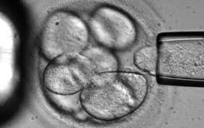
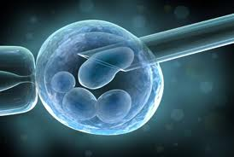
STEM CELLS

